**Install CDS**

[**Download the Eclipse IDE and add the ABAP Development Tools (ADT) Plugin | SAP Tutorials**](https://developers.sap.com/tutorials/abap-install-adt.html)

**CDS tutorial**

[Learn CDS View Development | Join in CDS View | CDS views in ABAP | CDS View | CDS View Example - YouTube](https://www.youtube.com/watch?v=4fVreuulweI)

After Installing

1. Click Abap Project 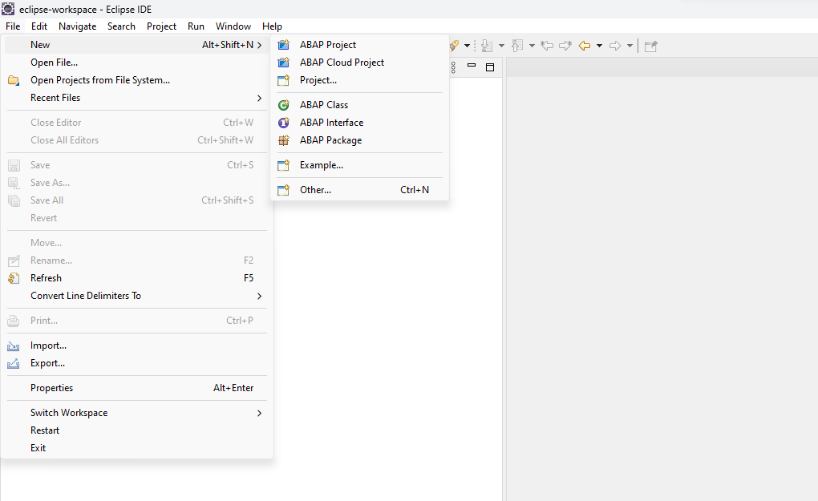
2. Click desire system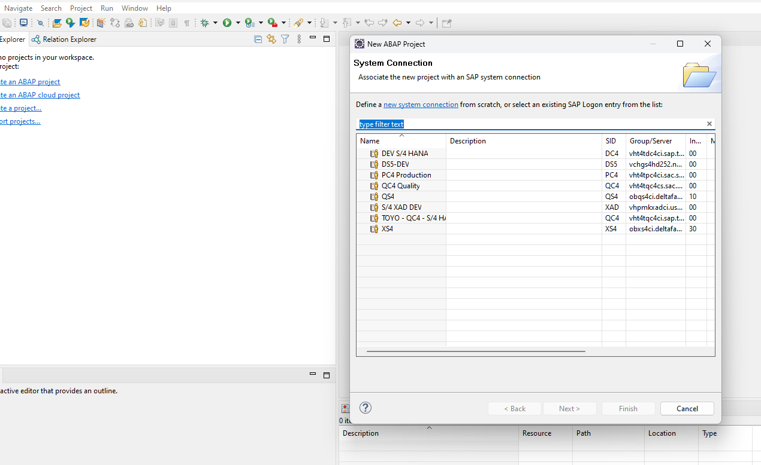
3. Check the configuration

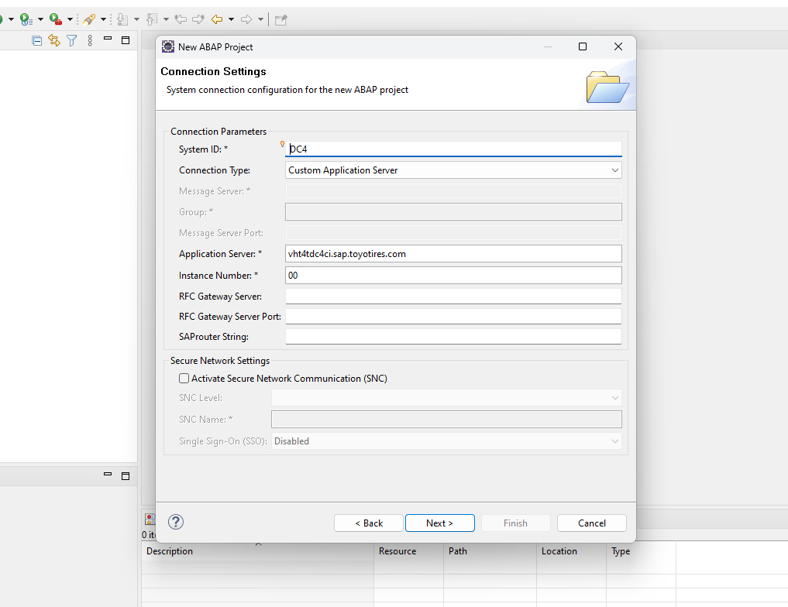

1. Enter the your credential

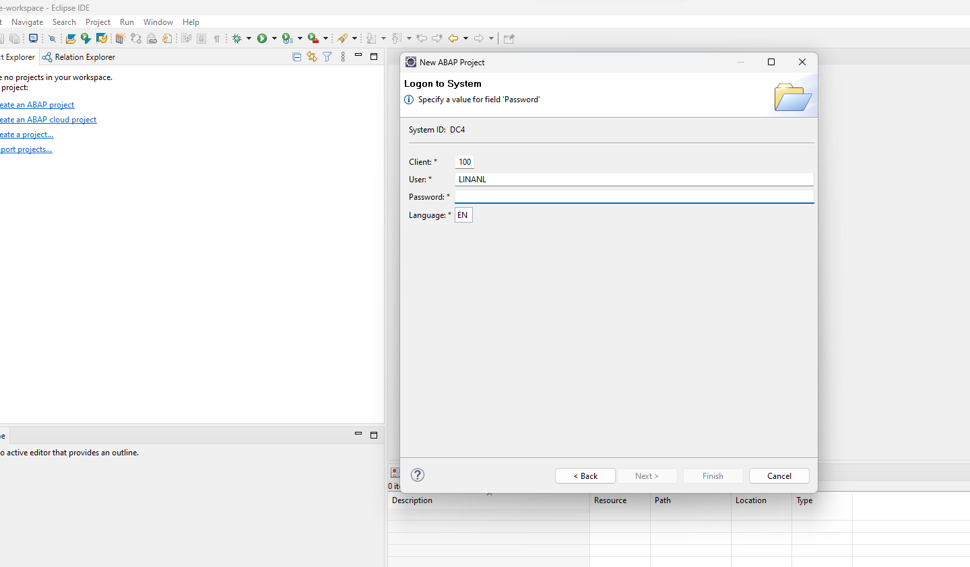

1. The credentials should save

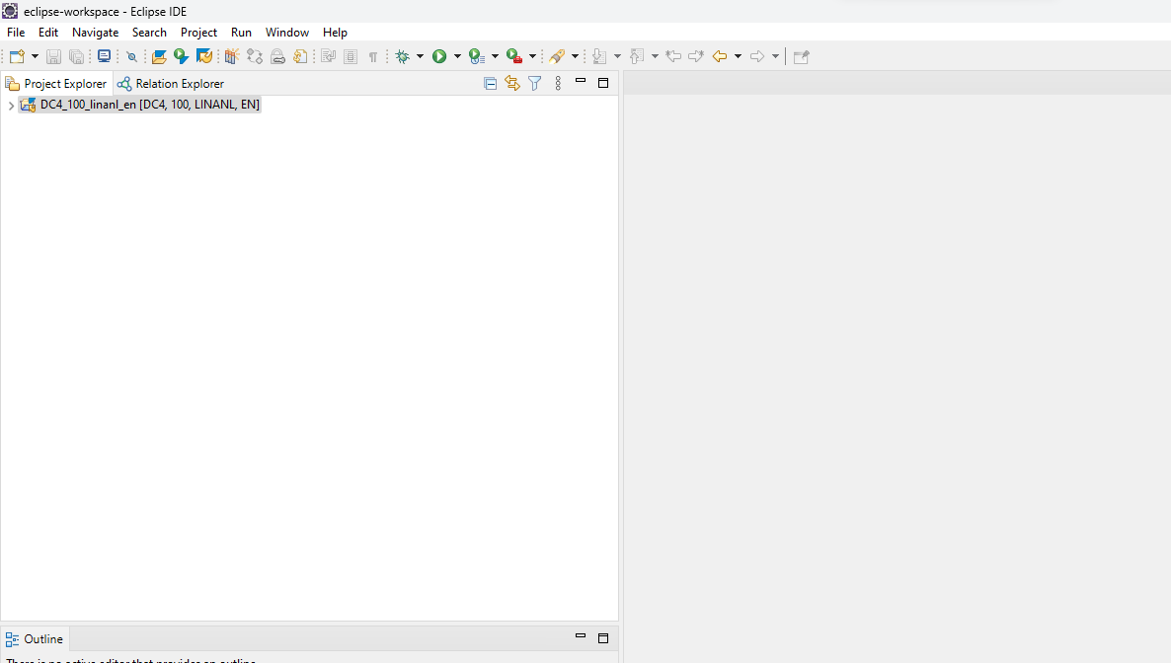

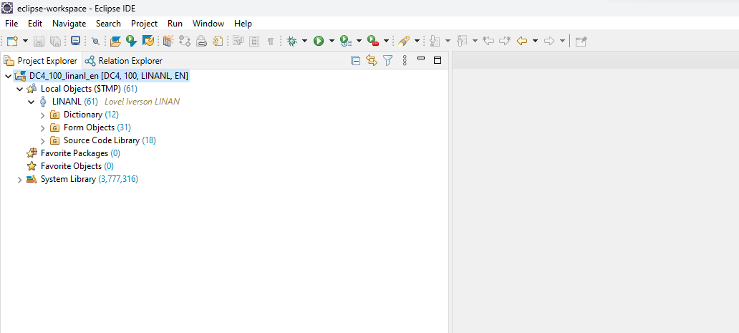

1. Enter Abap Repository Object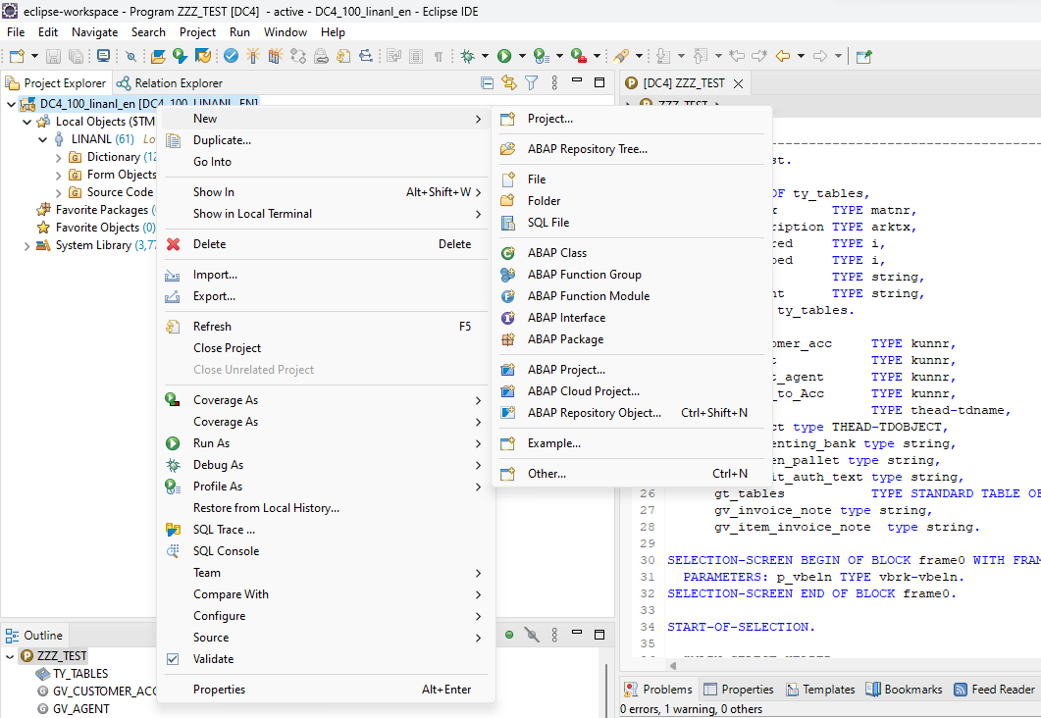
2. Enter Core data and select Data Definition

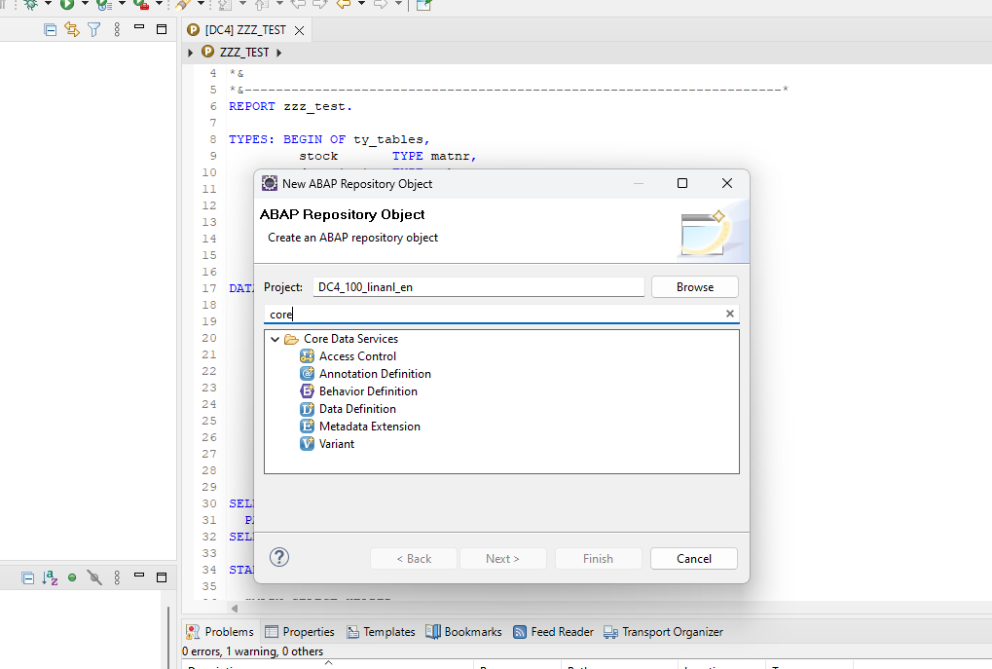

1. Provide name and description and proceed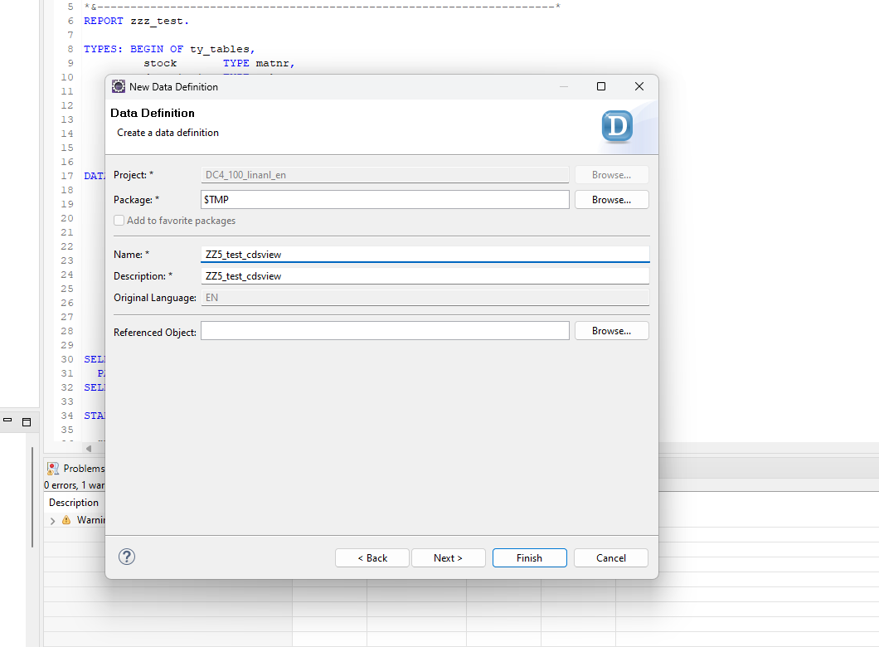
2. Select define view and select finish

